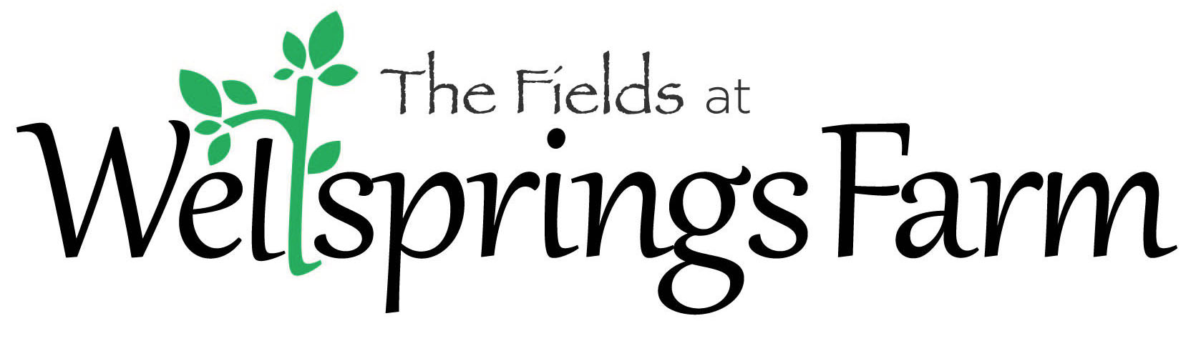

Welcome! To make your stay more comfortable please review the information below. Feel free to call the farm at 320-274-1860 if you have any further questions or call Karla at 612-425-6261 if you have any questions about reservations..

INFORMATION SHEET

The Wellness Center is the reception area. Upon arrival please check in there.

Check-in is at noon and check-out is 11:00 am from the hermitages unless otherwise arranged. We ask that at check in you would sign the guest book with date, your name and Member’s name (if different) and the hermitage. At checkout we would invite you to write comments.

Member/guests are welcome to come early and stay later than check in/out times to enjoy other aspects of the farm- e.g. walk the labyrinth, read in the Wellness Center or reflect in the chapel.

**There is no running water in the hermitages so at check-in members/guests can pick up and fill an insulated water container in the Wellness Center for their use.

The Wellness Center also has these amenities:
Flush Toilet and Shower
Sauna
Massage room (massage available by appointment - see below to schedule)
Spiritual direction room/Meeting space (spiritual direction available by appointment - see below)
Reflection Materials
Wi-fi available soon
Kitchenette with:
Full size refrigerator
Dining table
Microwave, hotplate and convection oven
Toaster, coffee maker and electric tea kettle
Plates, cups and other kitchenware
Simple cooking supplies plus salt/pepper, oil, sugar

Food: The Fields at Wellsprings Farm is licensed as a bed and breakfast only. Simple breakfast food items will be available in the Wellness Center. For other meals members/guests are welcome to bring their own food. Assorted frozen meals (Amy’s Organics and other brands) will also be available for individual purchase from the freezer in the Wellness Center. Items range in price from $2 to $5. Payment via check should be made out to The Fields or cash- though we do not have the ability to make change. Connie Delgado, an experienced local chef does do catering for groups at Wellsprings Farm. Connie uses organic, local foods whenever possible providing delicious and healthy meals. Connie’s bio is on the website on the bottom of The Farm page.

* If you have any food allergies please let us know so we can try to assist you when possible.
Each hermitage is accessible by car, has electricity and the following amenities:
Air Conditioner and Fan
Compost Toilet and/or Porta Potty
Baseboard heating
Fireplaces or Wood Burning Stove (House of Clare)
Bedding
Towels - Kitchen and Bath
First aid kit
Flashlights
Kitchenette with:
Microwave and Hot Plate
Electric tea kettle, Coffee Maker with Coffee, Tea, Hot Cocoa
Small Refrigerator
Plates, Cups and other Kitchenware
Sink or dish tub
Cleaning Supplies

Additional Items to Bring:
Personal toiletries and comfortable clothing, refreshment/food items as desired, and reading/reflection material. Plus bug spray, sunscreen, walking shoes, swimming gear and beach towel for summer- warm hiking clothes for winter.

Massage: One aspect of the mission is to create healing space for body, mind and spirit. If interested in getting a healing massage while you are at the farm, you can call Roxanne or Becky directly to make an appointment; both are gifted and experienced massage therapists. Their bios can be found on the website, at the bottom of “The Farm” page.

Roxanne Wagner call or text 651-271-6696 or email roxanne.wagner@gmail.com
Becky Ulrich call or text 952-443-2749 or email becky55386@yahoo.com

Spiritual Direction: Another aspect of the mission is to create reflective space fostering individuals to “drink from their own well” of wisdom and knowing. If interested in doing a spiritual direction session to explore what may be “bubbling up” or surfacing for you on retreat, you can call Julie directly to make an appointment. Julie has spiritual direction certification and is honored to accompany people on their spiritual journey.

Julie Surma 763-682-4971

